Transactional Vs Transformational Leadership

Transactional Leader:
“approaches followers with an eye to exchanging one thing for another” … Burns

“pursues a cost benefit, economic exchange to met subordinates current material and psychic needs in return for “contracted” services rendered by the subordinate “…. Bass

Transformational Leader:
“recognizes and exploits an existing need or demand of a potential follower… (and) looks for potential motives in followers, seeks to satisfy higher needs, and engages the full person of the follower” … Burns

“The leader who recognizes the transactional needs in potential followers “but tends to go further, seeking to arouse and satisfy higher needs, to engage the full person of the follower … to a higher level of need according to Maslow’s hierarchy of needs” … Bass

As exactly said by Bass – “the transactional leaders work within the organisational culture as it exists; the transformational leader changes the organisational culture”.

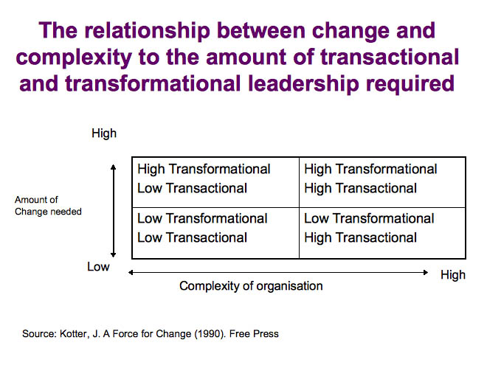

Transactional Vs Transformational Questionnaire

Identifying the self-beliefs and perceptions that help to determine your unique leadership style

Leadership style describes the manner and approach we use to provide direction, implement plans, and motivate people to deliver. It is determined by a number of factors and considerations over which we have some degree of control. We choose our leadership style either consciously or unconsciously for reasons that allow us to express our values and to reinforce those things in which we believe. There are many different kinds of leadership style that range from autocratic to democratic forms of behaviour. These describe preferred behaviours and actions when engaging with others.

This short diagnostic tool attempts to measure the degree to which your leadership style is more inclined towards either transactional or transformational modes of behaviour. It is unlikely that you will by definition be either one or the other instead demonstrating a preference or inclination that is stronger than the other.

This exercise will help to provide clarity on aspects of your personal leadership style that are either unconsciously driven or ritualised in patterns of behaviour that over time have become key features of your modus operandi. Developing insight into your personal leadership style will help to increase your choice and control over those behaviours that may undermine your success in certain circumstances.

Instructions
For each of the following ten pairs of statements, divide five points between the two according to your beliefs, perceptions of yourself, or according to which of the two statements characterise you better. The five points may be divided between the A and B statements in any way you wish with the constraint that only whole positive integers may be used.

Weigh your choices between the two according to the one that better characterises you or your beliefs.

 | A | As leader I have a primary mission of maintaining stability | ____
 | B | As leader I have a primary mission of change | ____
 | A | As Leader I must cause events | ____
 | B | As Leader I must facilitate events | ____
 | A | I am concerned that followers are rewarded equitably for their work | ____
 | B | I am concerned about what my followers want in life | ____
 | A | My preference is to think long range: what it might be | ____
 | B | My preference is to think short range: what is realistic | ____
 | A | As a leader I spend considerable energy in managing separate but  related goals | ____
 | B | As a leader I spend considerable energy in arousing hopes, expectations  and aspiration among my followers. | ____
 | A | While not in a formal classroom sense, I believe that a significant part of my leadership is that of a teacher | ____
 | B | I believe that a significant part of my leadership is that of a facilitator | ____
 | A | As a leader I must engage with followers at an equal level of morality | ____
 | B | As a leader I must represent a higher morality | ____
 | A | I enjoy stimulating followers to want to do | ____
 | B | I enjoy rewarding followers for a job well done | ____
 | A | Leadership should be practical | ____
 | B | Leadership should be inspirational | ____
 | A | What power I have to influence others comes primarily from my ability  to get people to identify with me and my ideas | ____
 | B | What power I have to influence others comes primarily from my status  position | ____

Your Leadership Style

Objective – To assess your personal propensity for transformational or transactional leader style.

Scoring Key

Transformational | Your Point(s) | Transactional | Your point(s)
1 B |  | 1 A
2 A |  | 2 B
3 B |  | 3 A
4 A |  | 4 B
5 B |  | 5 A
6 A |  | 6 B
7 B |  | 7 A
8 A |  | 8 B
9 B |  | 9 A
10 A |  | 10 B
Column totals

The higher column total indicates that you agree more with, and see yourself more like, either a transformational leader or a transactional leader.

After completing the scoring, you are encouraged to compare and discuss with colleagues.

(Source: John R. Schermerhorn, Jr, James G.Hunt and Richard N. Osborn (1991),
Managing Organizational Behaviour, Fourth Edition, pp. 484-5.)

